Tab 1
Task 1::
What are streams in java?

Stream in Java is a tool to process data (like a list) step by step.
You can filter, change, and collect results without using loops.

Task2::
Before Java 8, we had to write a lot of boilerplate code — that means repetitive, low-level code like for loops, if checks, and manual list building.
Task 3:

List of Intermediate and terminal operations
🔁 Intermediate Operations
(These return a stream and are used to build the pipeline)

Method | Purpose
filter() | Filters elements based on a condition
map() | Transforms each element
sorted() | Sorts the elements
distinct() | Removes duplicates
limit(n) | Limits the stream to first n elements
skip(n) | Skips the first n elements
flatMap() | Flattens nested structures
peek() | Used for debugging (like println)

🏁 Terminal Operations
(These trigger the stream processing and produce a result)

Method | Purpose
forEach() | Performs an action on each element
collect() | Collects elements to a collection
toArray() | Converts stream to an array
count() | Counts the number of elements
reduce() | Reduces elements to a single value
min() / max() | Finds the min/max element
anyMatch() | Checks if any element matches condition
allMatch() | Checks if all elements match
noneMatch() | Checks if no elements match
findFirst() | Returns the first element
findAny() | Returns any element (useful in parallel streams)

Task4::
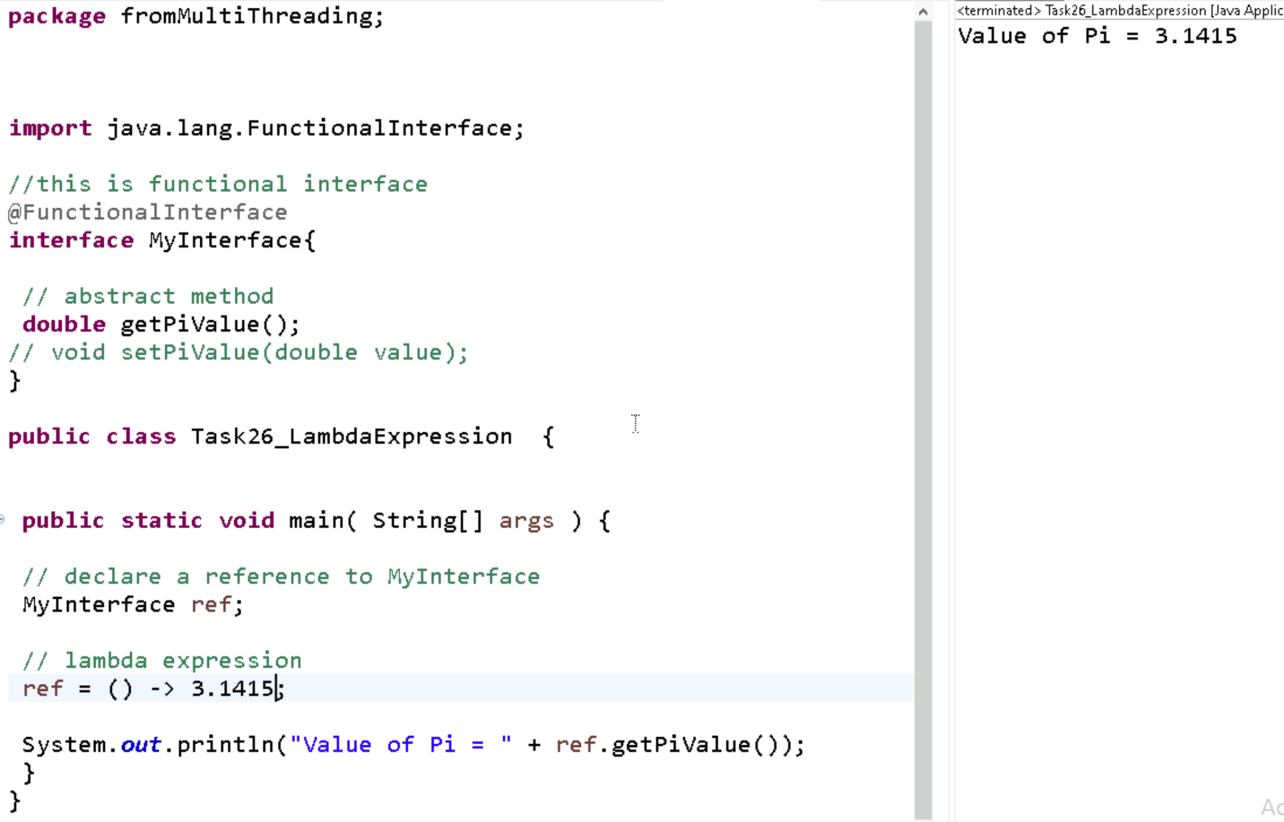

Task5::
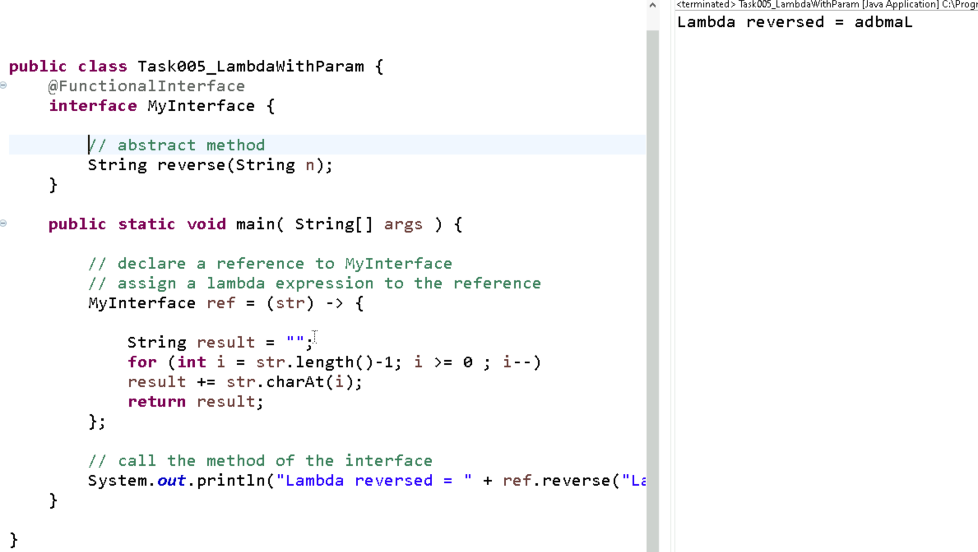

Task6 ::
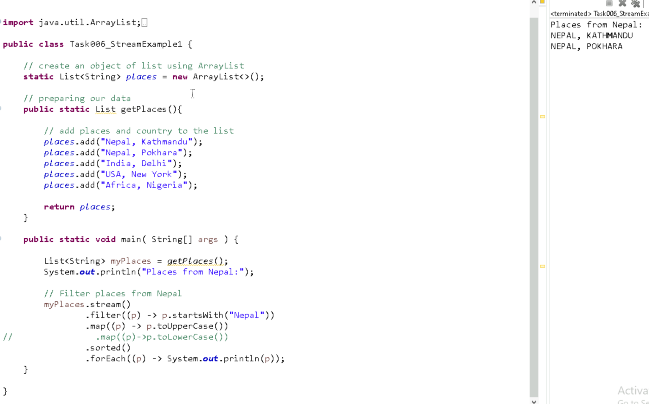
Task7::
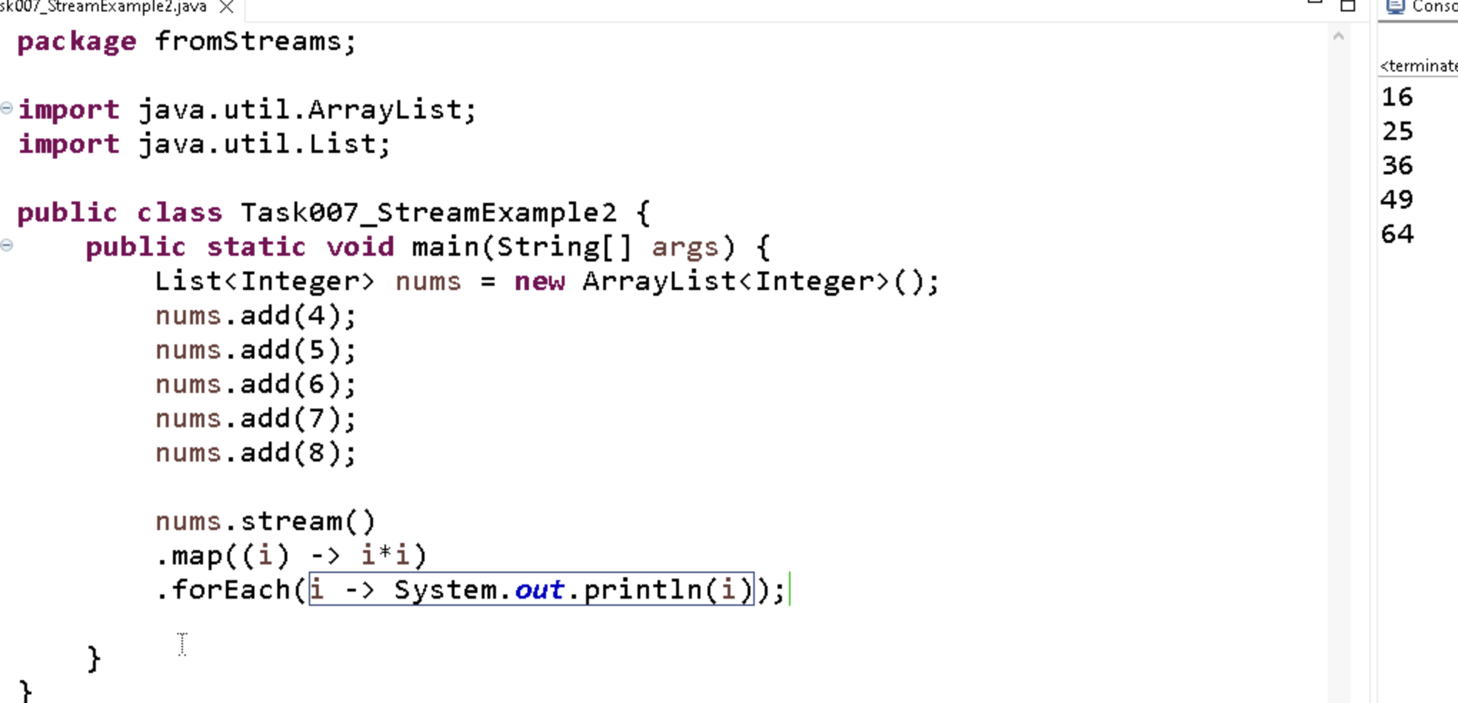

Task8 ::
map() is used in streams to change each element into something else.
For example, it can convert names to uppercase or numbers to their squares.

Task9::
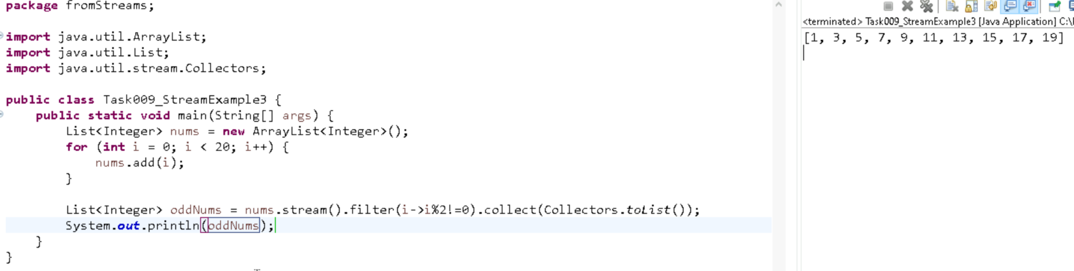

Task 10:

What do you understand by filter()?

filter() is used in streams to keep only the elements that match a condition.
For example, it can keep only even numbers or names starting with "A".

Task11::
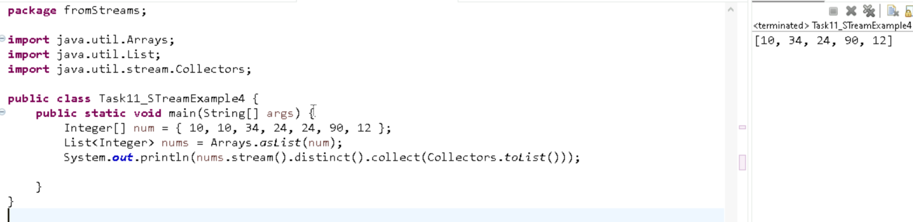

Task12:

What do you understand by distinct()?
distinct() is used in streams to remove duplicate elements.
It keeps only unique values from the stream.

Task13::
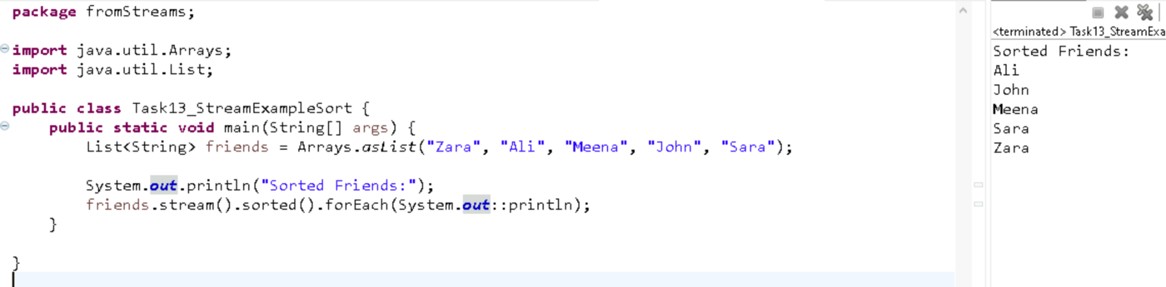

Task14::
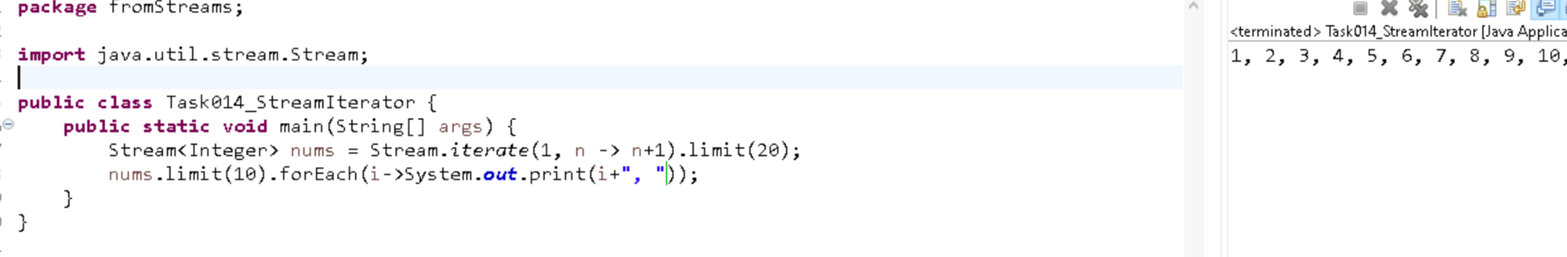

Task15::
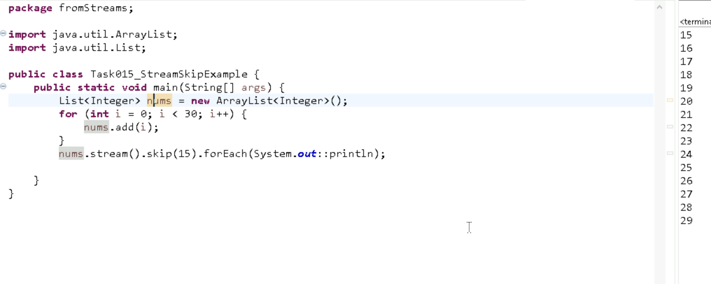
Task16::
limit(n) means "take only the first n items from the stream."
It helps if we want only a few results.
skip(n) means "ignore the first n items and work with the rest."
It’s useful when we don’t want the beginning part.

Task17::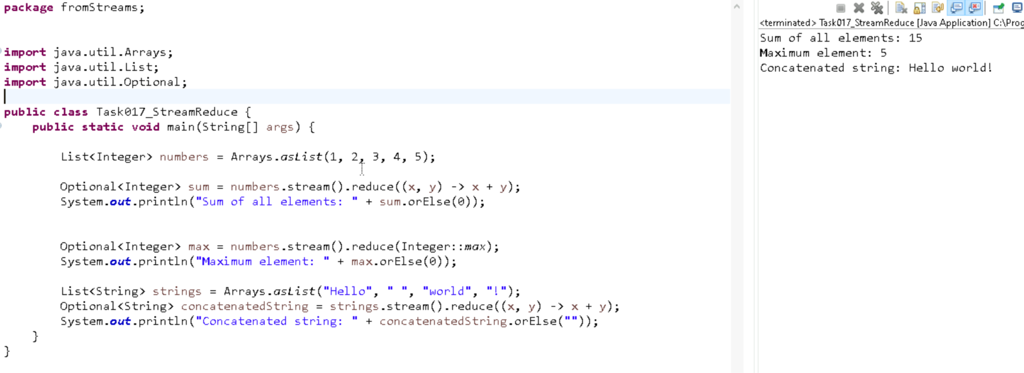
Task18::
Less Code – Streams reduce boilerplate code using functional-style operations.
Readable – Code is cleaner and easier to understand.
Efficient – Supports lazy evaluation and parallel processing for better performance.
Flexible – Easy to filter, map, sort, and collect data.
Immutable – Stream operations don’t change the original data.

Task19::

Error Type | When? | Common Examples
Compile-Time | Before running | Missing ;, wrong variable, type errors
Run-Time | While running | NullPointerException, /0, index error

